**ONLINE RAILWAY RESERVATION SYSTEM**

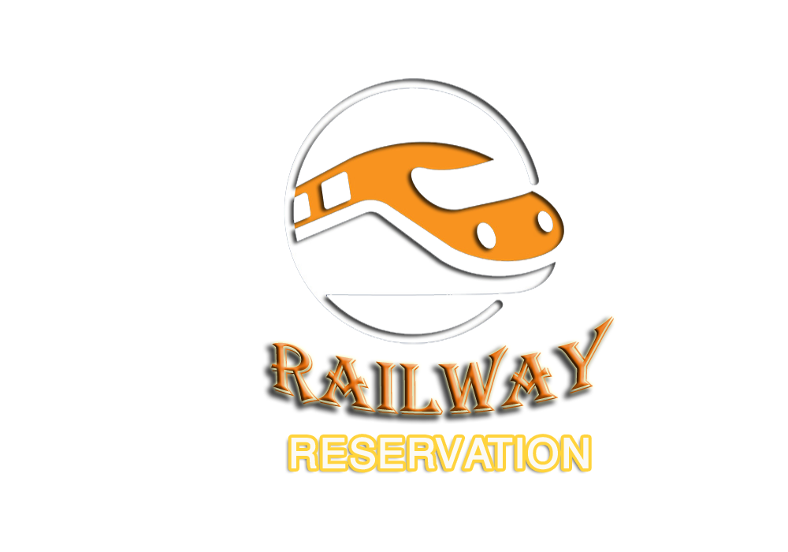

**Table of contents**

* Certificate of Completion.
* Problem Definition.
* Hardware and Software Requirements.
* Customer Requirement Specification.
* Project Plan.
* Task Sheet.
* E-R Diagrams.
* Algorithms.
* GUI Standards Document.
* Interface Design Document.
* Project Review and Monitoring Report.
* Unit Testing Check List.
* List of Validation.
* Final Check List.

**Certification of Completion**

**This to certify that**

SANA AZMAT KHAN

**Has Successfully Developed And Build The Assigned Project Named As Online Railway Reservation And Management System.**

**PROBLEM DEFINITION**

**Introduction**

The problem statement is attached separately in a file “FurnitureSystem.doc”

**Standards plan:**

Every code block must have comments.

The logic of the program needs to be explained. Proper documentation should be

Maintained.

Complete Project Report along with synopsis, code and documentation should be

Prepared.

**Documentation:**

No project is complete without documentation. In fact, it is one of the most

Important activities during the development of a project. The documentation of an

ideal project will be in the form of a project report.

**Hardware/ Software Requirements**

**Hardware:**

A minimum computer system that will help you access all the tools in the

Courses is a Pentium 166 or better

128 Megabytes of RAM or better

**Software:**

* + - Visual Studio .Net / ASP
    - IIS server
    - .Net Framework
    - Java Virtual Machine/ J2EE server
    - Notepad/Java editor
    - j2sdk1.4.1_02 (or later).
    - EJB Dev Kit
    - Java enabled web server
    - JSP / Servlets Dev. Kit

**Railway** **Reservation & Management System**

Indian Railways is one of the largest rail networks in world. Majority of people used to travel in train which is convenient and affordable means of transport. So keeping this in view, the reservation of railways is a most important task and it must be faster and efficient as the demand (travellers) is very high. In order to meet this demand, manual reservation is cumbersome and it requires an efficient program to implement the online reservation.

This Application enables us to choose the train even there is no necessary to fill a form at the railway reservation counter ,i.e. we can directly select from the choices provided for us with train numbers and their origin, departure time, destination & arrival time at that station and the class to travel in. Application gives us the final output as train ticket with the amount to be paid.

**Customer Requirement Specification**

**Railway Reservation System – Modules**

**Security module** - Security modules include security features like user management and application level password management.

* Maintain user master- Each user identified by the user name and user type. Only admin user can create, edit user information.
* Password must be alpha numeric.
* While creating user system assign default password for the user
* Password of user are encrypted for the security purposes.
* Access level and roles and privileges are set for different type of users.

**Master Management module**s-

Master management module includes following sub modules.

* **Station Master** – Every station is uniquely identified by system generated Station ID. It also includes station code, station name and railway division name.
* **Train Master** – Every train uniquely identified by train no, it includes train name, train name, up/down status, route id., Number of coaches available for 3 tier AC, First Class, Sleeper Class etc.
* **Train Schedule** – It includes train journey details from start station to end station, all in between station, distances between 2 station, arrival and a.
* **Fare Rule** – It help to calculate fare by distance, support different type of fare calculation for different class like AC1, AC3 etc.
* **Cancellation Fees Rule** - It provide the master data for all ticket cancellation fees calculation.
* **Reservation and Super-Fast Fees** – It provide the master data for all ticket reservation fees calculation and super-fast fees.
* **Day Master -** It includes information of train schedule which days of the week train will run.

**Transaction Module** - Transaction module includes following sub modules.

* **Reservation** – This module used to make reservation, it asks for input data like train no, journey date, from station code, end station code. System has powerful validation rule to check validation like journey date must be greater than system date, journey date must be within 90 days. Train should run for the selected day. Check for from station and to station. Seat availability, while saving the record system generate PRN no, seat no and coach no. Before save the system ask for final confirmation. System automatically calculates the fare and save the details.
* **Cancellation** – For cancellation of ticket it ask for PRN no, after entering the correct PRN no system check for validity of the PRN no, whether it already cancelled, journey date already expired. I it validate system display all the details of the reservation. System automatically calculates the cancellation fees from the cancellation rule master. Before save the record system ask for the confirmation.
* **Update Seat no for unconfirmed passenger** – It is schedule activity, system query for all cancelled ticket for particular journey date and allocates all vacant seats to unconfirmed passenger.
* **Daily Cash Transaction** – It shows daily transaction, like how much money received and how much money refund. All data can be exported to MS Excel for review and save in file system.

**Query Module** – Query module contains the following information:

A powerful query module give on screen information for particular PRN NO, it shows all the reservation details and cancellation details, include current status for the seat no, coach no.

The tables required in the application are as follows:-

a. Passenger detail

|  |  |  |
| --- | --- | --- |
| Field | Type | description |
| PNR no | numeric | Pnr no should be unique |
| Name | Varchar | Name of the passenger |
| age | numeric | Age of the passenger |
| gender | char | Gender of the passenger |
| Total Passenger | numeric | Number of passenger |
| Date of Travel | Varchar | Date of travel |
| class | Varchar | Class in which the passenger is travelling. |
| Train no | Varchar | Train no |

b. Train details

|  |  |  |
| --- | --- | --- |
| Field | Type | description |
| Train no | numeric | Train no should be unique |
| Train Name | Varchar | Name of the train |
| Route from to | varchar | Route of the train |
| Departure time | Time | Time of the departure |
| No. of compartment | numeric | Total no of compartment available in the train |
| 1AC | numeric | Total no of compartment of 1AC |
| 2AC | numeric | Total no of compartment of 2AC |
| 3Ac | numeric | Total no of compartment of 3AC |
| Sleeper | numeric | Total no of compartment of Sleeper |
| General | numeric | Total no of compartment of General |
|  | numeric |  |

c. Login detail

|  |  |  |
| --- | --- | --- |
| Field | Type | description |
| LOGIN_ID | AutoNumber | Auto generated for particular user |
| LOGIN_NAME | varchar | Login name |
| LOGIN_PASSWORD | varchar | Login password |

Fare Detail:-

|  |  |  |
| --- | --- | --- |
| Field | Type | description |
| distance | numeric | Distance between source and destination |
| Type of compartment | numeric | Type of compartment in which travelling |
| Type of train | varchar | Type of train in which travelling |

Note: student can add table if they require.

# **PROJECT PLAN**

1. Analysis -1 -7.
2. Design - 4-16.
3. Development - 9*--26.
4. Testing - 24-28.
5. Documentation - 28-30.

|  |  |  |  |  |
| --- | --- | --- | --- | --- |
| **Analysis** | **Design** | **Development** | **Testing** | **Documentation** |

|  |  |  |  |  |  |  |  |  |  |  |  |  |  |  |  |  |  |  |  |  |  |  |  |  |  |  |  |  |  |
| --- | --- | --- | --- | --- | --- | --- | --- | --- | --- | --- | --- | --- | --- | --- | --- | --- | --- | --- | --- | --- | --- | --- | --- | --- | --- | --- | --- | --- | --- |
| 1 | 2 | 3 | 4 | 5 | 6 | 7 | 8 | 9 | 10 | 11 | 12 | 13 | 14 | 15 | 16 | 17 | 18 | 19 | 20 | 21 | 22 | 23 | 24 | 25 | 26 | 27 | 28 | 29 | 30 |

* Each phase must be complete as shown by the lines.
* The team would meet day by day and evaluate their progress. Detailed progress plan to be drawn to access progress of the project.
* As it can be noticed that there are overlapping of process this is kept because certain process can go hand in hand with other processes.

**Task Sheet**

|  |  |  |  |  |  |
| --- | --- | --- | --- | --- | --- |
| **S.No** | **Task** | **Project Title** | **Actual Start**  **Date** | **Actual Days** | **Status** |
| **OWSM** |
| 1. | Case Study | | 25-April-2019 | 5 | Completed |
| 2. | Graphics Designing | | 30- May -2019 | 7 | Completed |
| 3. | Material Searching | | 07- May -2019 | 2 | Completed |
| 4. | Development | | 09- May -2019 | 12 | Completed |
| 5. | Testing | | 21-May-2019 | 2 | Completed |
| 6. | Documentation | | 23-Feb -2019 | 2 | Completed |

**ER Diagram**

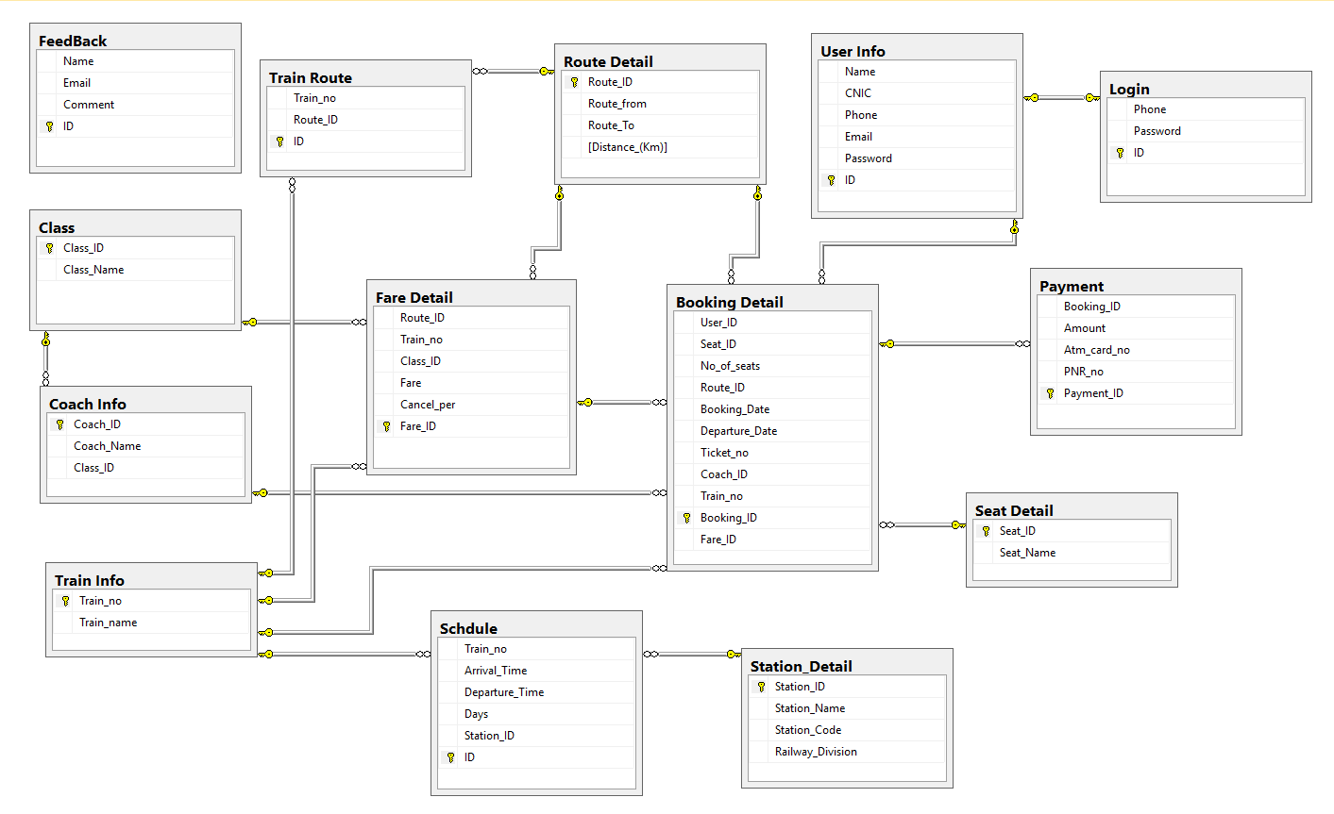

**Algorithms**

SELECT LOGIN

YES

AS ADMIN

ADMIN LOGIN

NO

YES

USER LOGIN

AS USER

NO

EXIT

NO

USER LOGIN

ADMIN LOGIN

ENTER LOGIN DETAILS

ENTER LOGIN DETAILS

YES YES

VALIDATION

VALIDATION

YES YES

ENTER RAILWAY RESERVATION

ENTER RAILWAY RESERVATION

SELECT MENU

USER LOGIN

ADMIN LOGIN

VIEW CATEGORY

ADD CATEGORY

VIEW TRAIN

ADD USER

GO TO PAGES

ADD PASSNGER DETAILS

GO TO PAGES

GIVE REVIEW

VIEW TRAIN ROUTS

ADD TRAIN DETAILS

MANAGE TRAIN TICKETS AND TIMINGS

VIEW USER

UPDATE TICKETS INFO

DELETE TICKETS INFO

ENTER COACH DETAILS

YES

VALIDATION

ENTER RAILWAY RESERVATION

ENTER PESSANGER DETAILS

ENTER TRAIN DETAILS

YES

VALIDATION

VALIDATION

ENTER RAILWAY RESERVATION

ENTER RAILWAY RESERVATION

ENTER TICKET DETAILS

NO YES

SEAT IS AVAILABLE

ENTER VALID DETAILS

NO YES

EXIT

PLEASE WAIT

SEAT IS NOT AVAILABLE

**Screenshots**

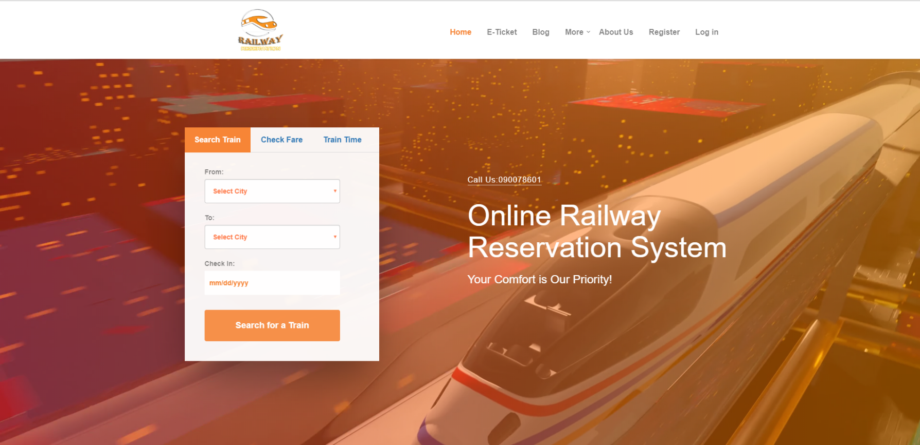**Header**

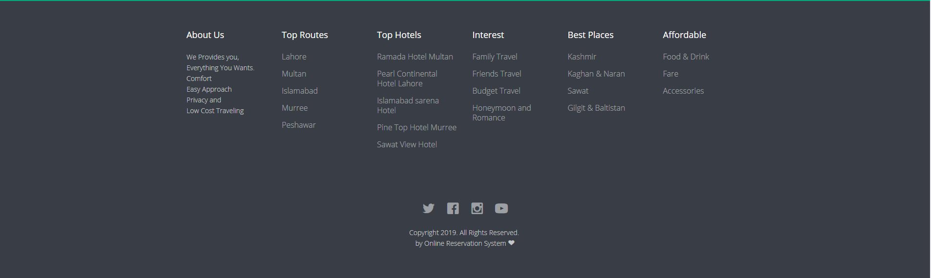

**Footer**

**Index**

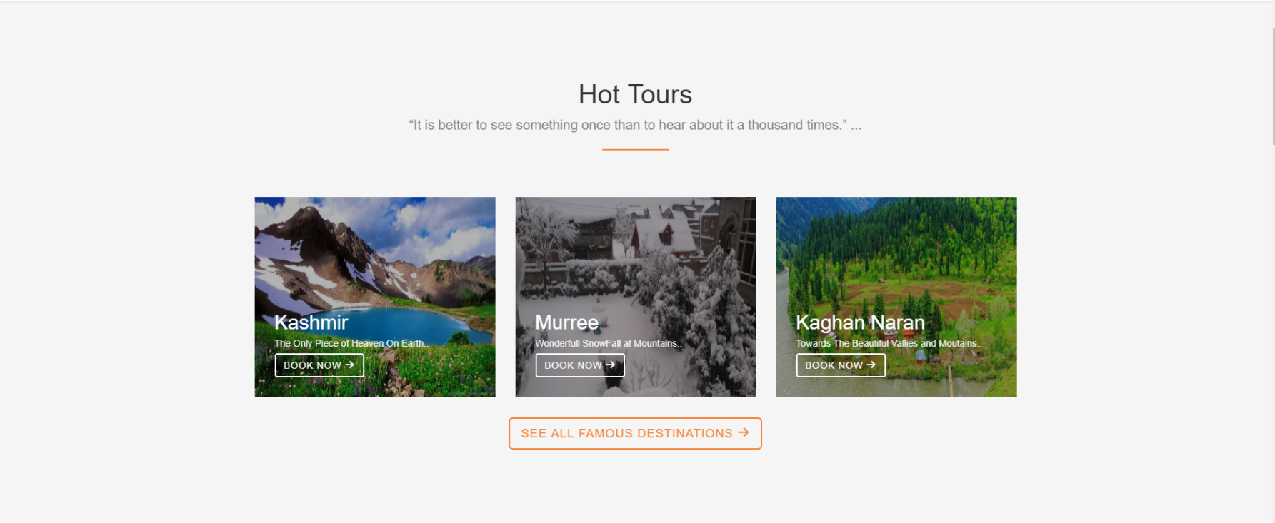



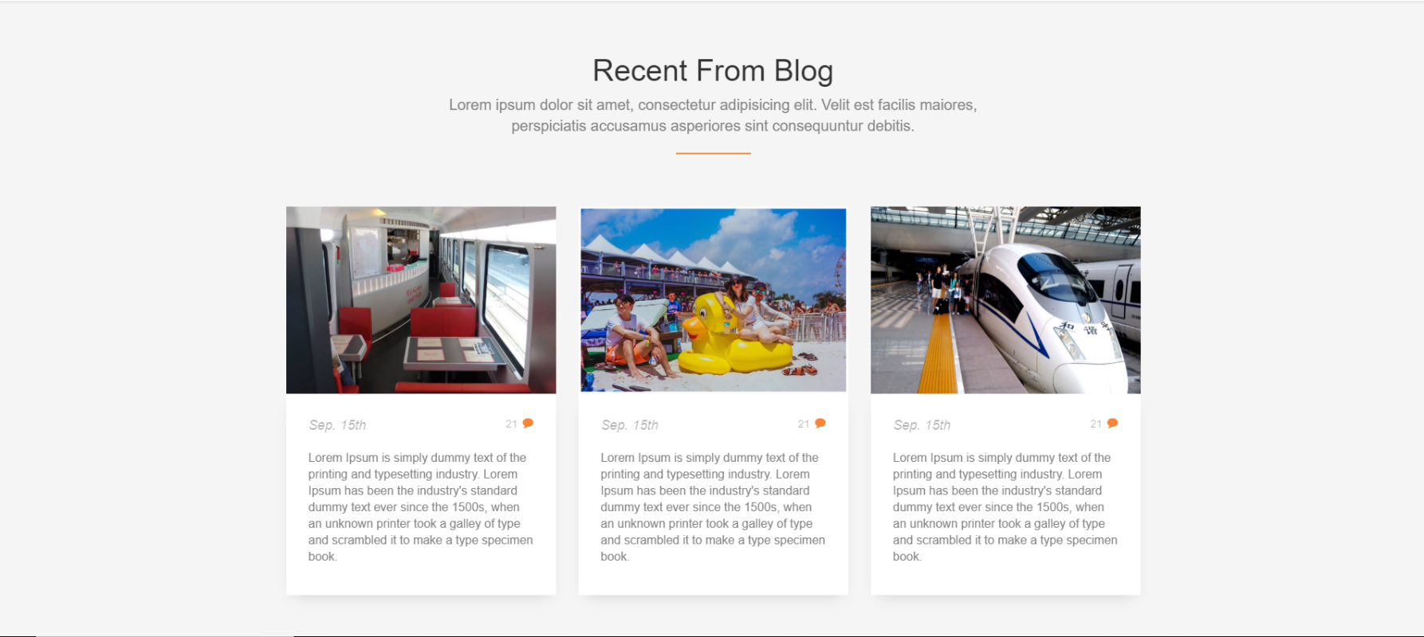

**Contact Form**

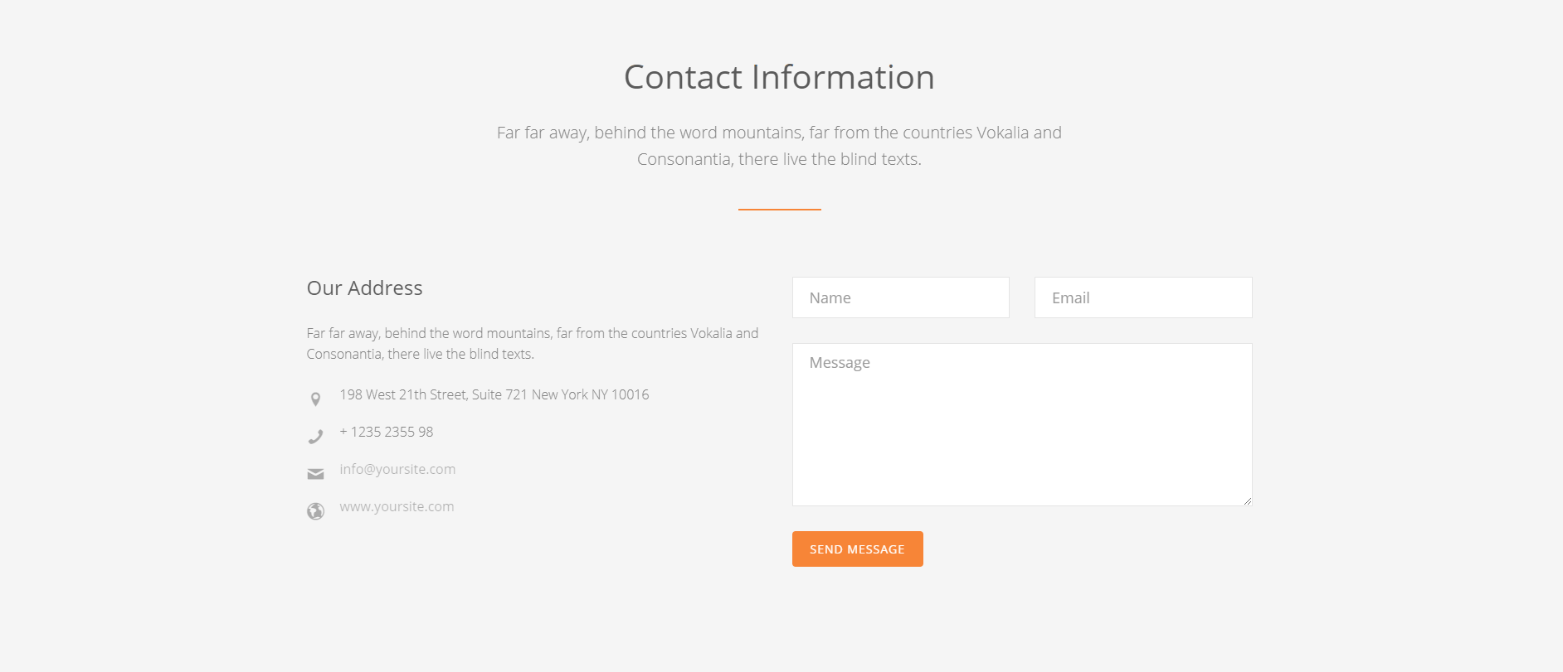

**Blog**

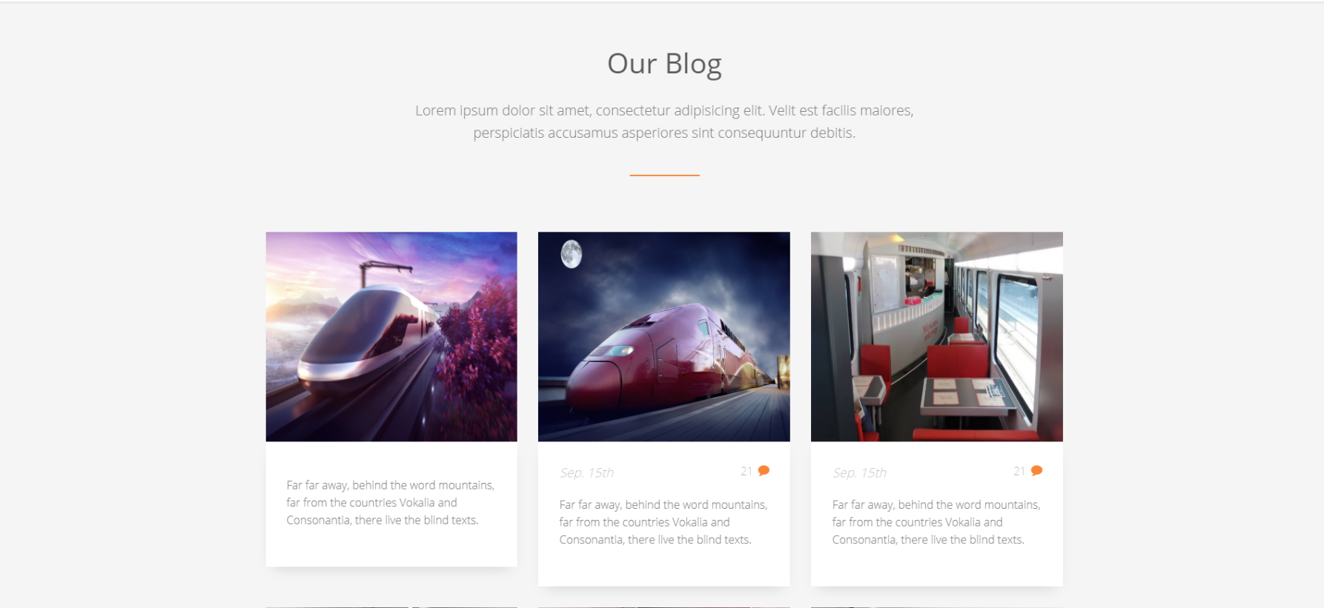

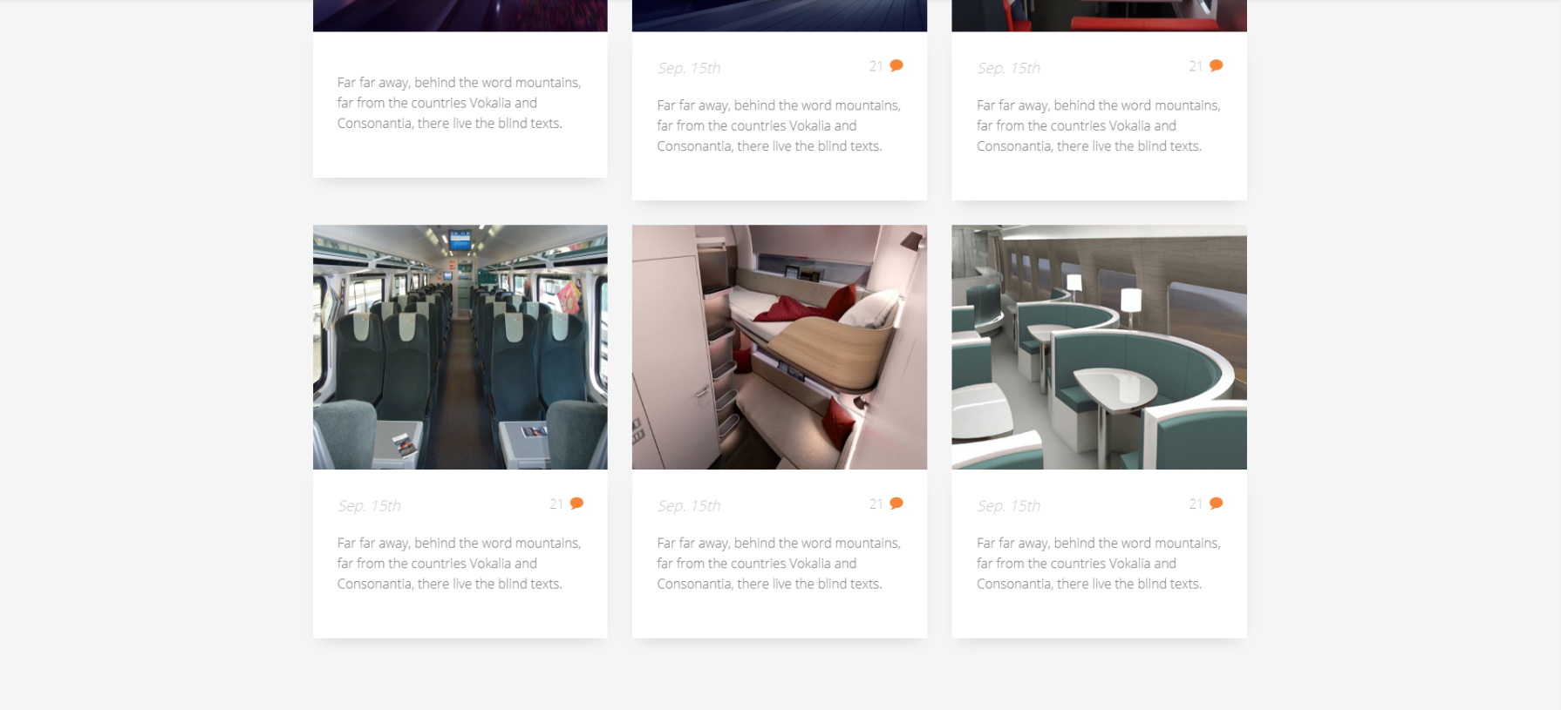

**Feedback**



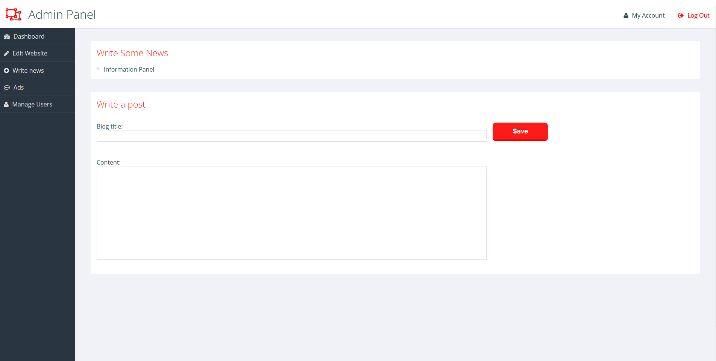**Admin Panel**

**LIST OF VALIDATION**

|  |  |
| --- | --- |
| **OPTIONS** | **VALIDATION** |
| All Forms have link back to Main Form | Yes |
| All Functions Are Compatible with  Visual Studios | Yes |

**FINAL CHECKLIST**

|  |  |  |  |  |
| --- | --- | --- | --- | --- |
| **S.No** | **LIST OF ITEMS** | **YES** | **NO** | **COMMENTS** |
| 1. | Do All Frames Linked together | Yes |  |  |
| 2. | All Frames working | Yes |  |  |
| 3. | Frames Colors As Per Common Guidelines | Yes |  |  |
| 4. | Visual Studios Compatible | Yes |  | Tested In  Visual Studios 2017 |
| 5. | Project Zip File | Yes |  | Created using  WinRAR |